Mongezi Mabuza

MD.2022.R9H1J1 | 13 SEPTEMBER 2024

DATABASE MANAGEMENT PROJECT 1

SQL SEVER

Project Objective

The project is intended to manage the accounts of every player that registers for the online game. This is will be achieved by the creation of tables, vies, stored procedures, triggers and indexes.

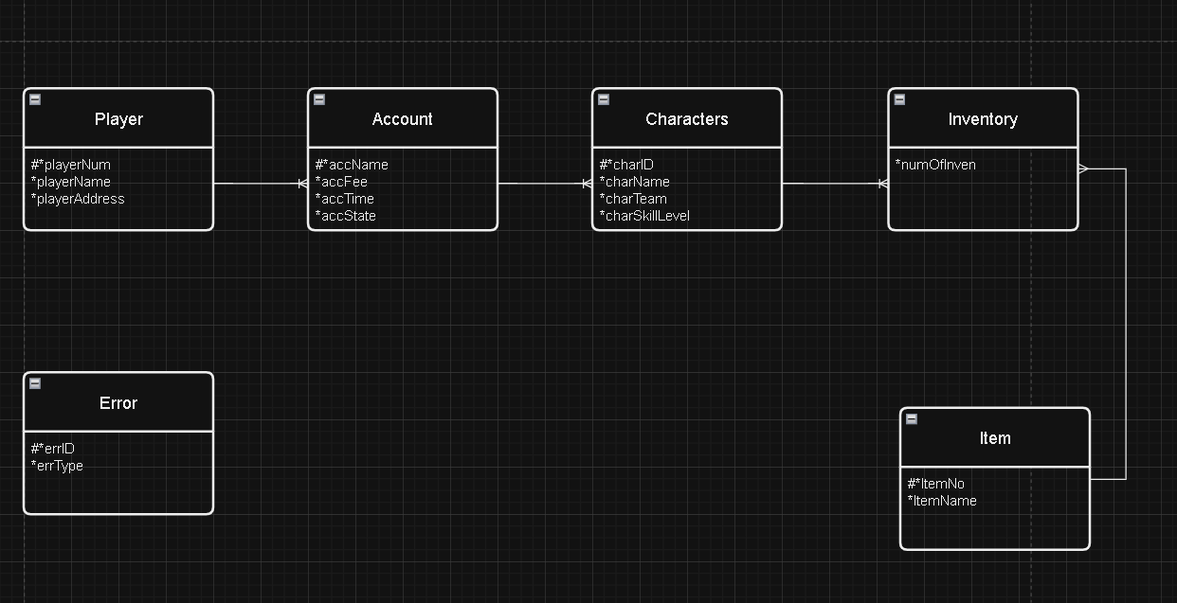

Database Creation

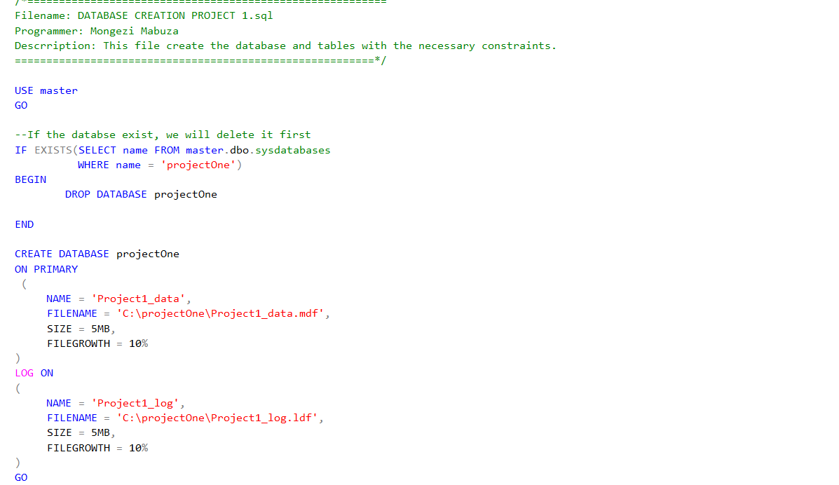

Data Inserts

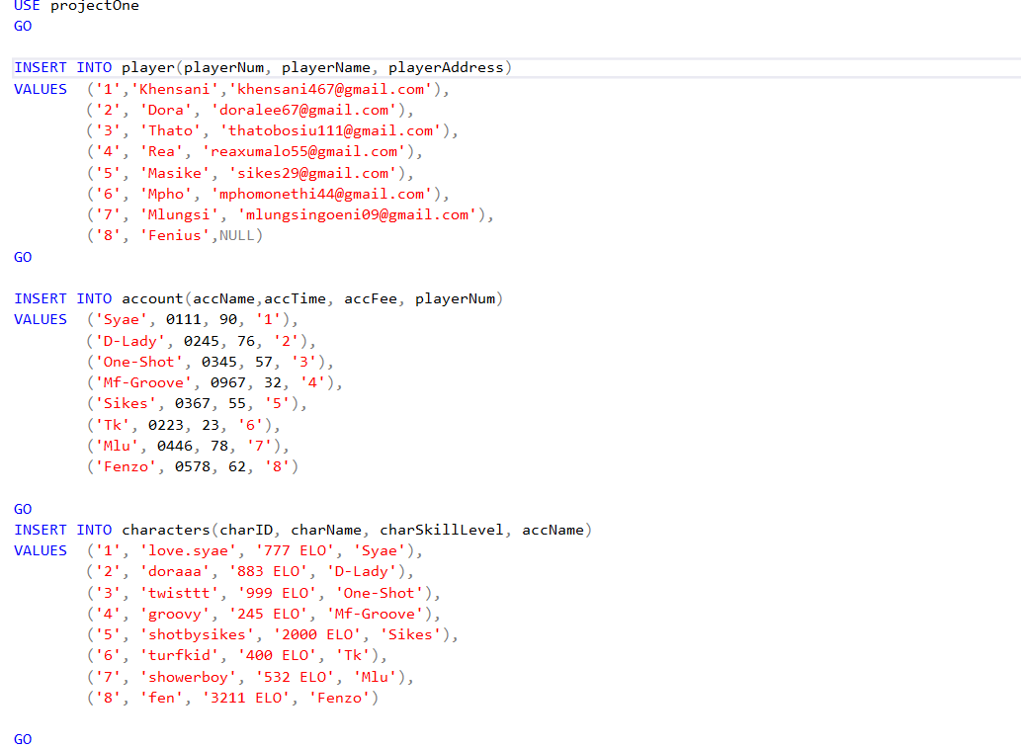

Create Views

Stored Procedure

433

Indexes

Trigger

Software used

Microsoft SQL Server Management Studio 20